Gynecomastia Surgery Recovery
As a plastic surgeon specializing in gynecomastia procedures one of the most important questions I get asked during the consultation is the recovery process. The most important thing to know about the recovery process is that it is just that…a process. In this post I will lay out the general timeline for recovery. The keyword is general as some patients recover faster and some slower.

Day of Surgery: Go home and relax. Walk several times to help with circulation as well as to use the restroom.
Day 1: Walk without restrictions. Diet is unrestricted, with the exception of very salty foods.
Day 3 to 4: Okay to drive if not on pain medications. Okay to return to work if it doesn’t entail physical labor.
Day 6: Sutures come out and compressive dressings come off. Continue wearing the compression vest.
4 weeks: Follow up to determine when to exercise and stop wearing compression vest (most men exercise between 4-6 weeks and scan stop wearing the compression vest around this time as well).
4 to 6 months: Final result of chest contour. Incisions look good much earlier than this but final incision healing is typically around 1.5 years.
Most men having this procedure go through this type of recovery process. It is important to have this discussion with the patient before surgery so they can plan their life accordingly. Many men spend years contemplating having gynecomastia surgery. It is important to carve out a small period of time to allow your body to heal after surgery.

To learn more about gynecomastia surgery and to see before and after photographs, visit www.losangelesgynecomastia.org.

Hard Lumps After Gynecomastia Surgery
As a plastic surgeon specializing in gynecomastia surgery, I spend a lot of time answering patient questions through emails and various internet forums. One of the most common topics of conversation is feeling firm lumps after surgery. Obviously men who have gynecomastia are all too familiar with firm lumps in their breast, especially under the areola. Thus it can be very disconcerting to feel these AFTER surgery. There is a simple way to differentiate what the lumps after surgery are:
- If the results of the surgery were initially very good with no lumps felt then the formation of these lumps (sometimes as early as 2 weeks after surgery) is usually scar tissue build up.
- If the lumps were palpable right after the surgery and have never reduced then it is likely excess tissue that was not removed.
Now not every lump needs to be treated. The most important thing is not whether it can be felt, but whether it can be seen. If it is scar tissue formation, then typically starting with finger massage can help break it up. If there is no improvement with this technique then careful kenalog injections can be performed to break up the scar tissue. In my practice this is not done frequently, however, when it is, it can take sometimes require 2 or 3 injections spaced 1 month apart to fully dissipate the scar. Only, and only if these two techniques do not help, do I then recommend surgery to remove the scar. This is extremely rare. Obviously, if there is excess tissue that is causing a visible fullness, then further surgery would need to be done to address this. I recommend, however, that patients wait six months to perform this surgery to allow not only proper assessment of what to remove, but also allow the original surgical area to settle.
To learn more about gynecomastia surgery and to see before and after photographs, visit www.losangelesgynecomastia.org.

Mondor’s Thrombophlebitis
From time to time, patients who undergo gynecomastia surgery come in for their 1 month follow up and say that they feel a firm, rope-like structure on their abdomen or chest. They usually say they noticed it around 2-4 weeks after surgery. Sometimes it is painful, sometimes not. Obviously they are very concerned especially because in some cases it occurs in an area which did not even undergo surgery.
The most important thing I can do is to reassure them. What they are referring to is Mondor’s cords or thrombophlebitis. This is an inflammation of the superficial veins that run under the skin in the upper abdomen and chest. They can become inflamed which leads to that hard rope- like feel. Mondor’s cords typically resolve on their own, although sometimes anti-inflammatories can be helpful with symptoms of pain. Below is an example of a patient of mine who underwent gynecomastia surgery without any procedures on his abdomen. One can see the Mondor’s cords on the image on the left at 4 weeks post-surgery. At his 3 month visit they are completely gone.
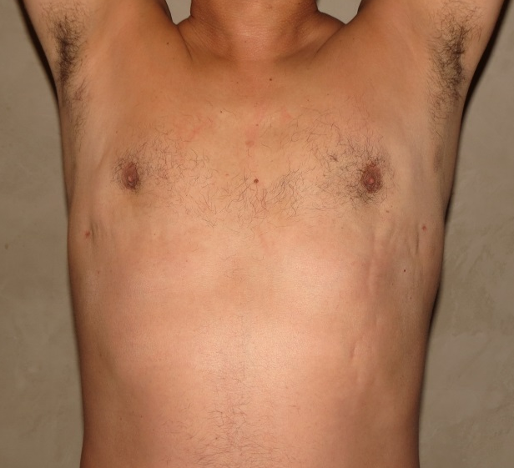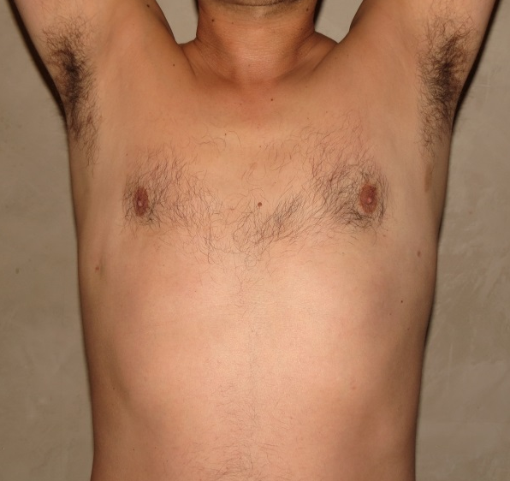
To learn more about gynecomastia surgery and to see before and after photographs, visit www.losangelesgynecomastia.org.

